**DAILY ONLINE ACTIVITIES SUMMARY**

|  |  |  |  |  |  |  |  |  |
| --- | --- | --- | --- | --- | --- | --- | --- | --- |
| **Date:** | **11-07-2020** | | | | | **Name:** | **Kanaka BS** | |
| **Sem & Sec** | **6th & A** | | | | | **USN:** | **4al17cs039** | |
| **Online Test Summary** | | | | | | | | |
| **Subject** | | **-** | | | | | | |
| **Max. Marks** | | **-** | | **Score** | | | **-** | |
| **Certification Course Summary** | | | | | | | | |
| **Course** | **Operating Systems** | | | | | | | |
| **Certificate Provider** | | | **-** | | **Duration** | | | **1.5hours** |
| **Coding Challenges** | | | | | | | | |
| **Problem Statement:**  **Python Program for Product of unique prime factors of a number** | | | | | | | | |
| **Status: Solved** | | | | | | | | |
| **Uploaded the report in Github** | | | | | **yes** | | | |
| **If yes Repository name** | | | | | <https://github.com/kanakabs/Daily-Status> | | | |
| **Uploaded the report in slack** | | | | | **yes** | | | |

**ONLINE COURSE**

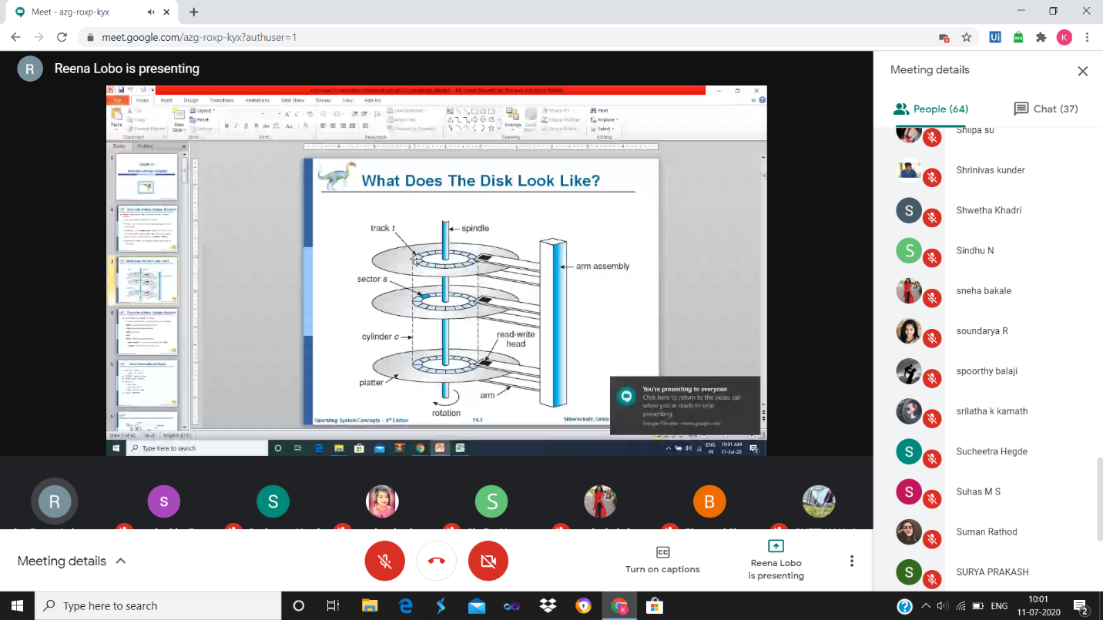

**ONLINE CODING**

**Python Program for Product of unique prime factors of a number**

def productPrimeFactors(n):

product = 1

for i in range(2, n+1):

if (n % i == 0):

isPrime = 1

for j in range(2, int(i/2 + 1)):

if (i % j == 0):

isPrime = 0

break

if (isPrime):

product = product * i

return product

n =18

print ("Product of unique prime factor of a number is:",productPrimeFactors(n))

**COURSERA**

